Doc 6 – v6 – S1 T3 – Information Sheet for Young People

**WHAT DO I DO IF I HAVE ANY QUESTIONS?**



**REACH is back!**

**Last year your year group took part in REACH. We’ll be back in the next few weeks to do it all again!**

**Please read the following information carefully**

**It will tell you why the research is being done and what you will be asked to do if you take part**

**INFORMATION SHEET FOR YOUNG PEOPLE**



If there is anything you don’t understand or if you have any questions you would like to ask then please do. You can contact us by phone or email, or visit our website:

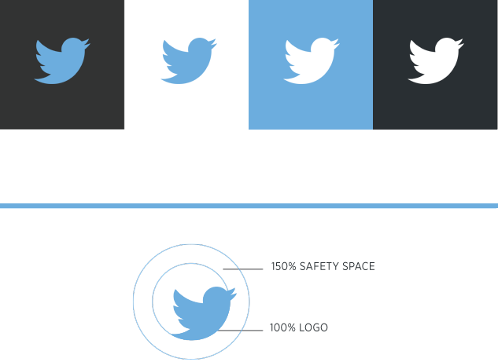

[www.thereachstudy.com](http://www.thereachstudy.com)

[reach@kcl.ac.uk](mailto:reach@kcl.ac.uk)

@TheREACHStudy

020 7848 0510

This research study has been approved by an independent group of people called the Psychiatry, Nursing and Midwifery (PNM) Research Ethics Subcommittee (RESC) (reference: HR15/162320). If this study harms you in any way, please contact the Chair of the PNM RESC at [rec@kcl.ac.uk](mailto:rec@kcl.ac.uk).

**WHAT DO I NEED TO DO NOW?**

If you have understood what we are asking and you do not have any more questions, please have a think about whether you want to take part in our study.

This is entirely up to you. It’s ok if you don’t want to take part and you will not have to explain your reasons. **You are also able to change your mind and stop taking part at any time and pull out of the study if you would like to.** If you change your mind before 30 August 2020, which is the end of the study, we will destroy all information we have from you. If you **do** decide to take part then you will need to sign a form to confirm this, which we will give to you.

If your parents told us last year that they did **not** want you to take part in REACH, we will assume you should not take part this year, unless your parents tell us otherwise.

If you have understood what we are asking and you do not have any more questions, please have a think about whether you want to take part in our study.

This is entirely up to you. It’s ok if you don’t want to take part and you will not have to explain your reasons. **You are also able to change your mind and stop taking part at any time and pull out of the study if you would like to.** If you change your mind before 30 August 2020, which is the end of the study, we will destroy all information we have from you. If you **do** decide to take part then you will need to sign a form to confirm this, which we will give to you.

If your parents told us last year that they did **not** want you to take part in REACH, we will assume you should not take part this year, unless your parents tell us otherwise.

**WHAT IS THE AIM OF THE RESEARCH?**

The aim is to understand what things lead to better mental health and what things lead to worse mental health in young people.

**WHO ARE WE?**

We are a group of researchers from a university called **King’s College London**. We do research to try to understand and improve people’s mental health.



**HOW CAN YOU HELP US?**

**WHAT DO WE MEAN BY MENTAL HEALTH?**

We need your help so that we can see how positive and negative life experiences and circumstances affect our mental health over time. There are 2 parts to this:

1. We will ask you to complete a questionnaire during lesson time. There will be questions about how you feel, things that have happened in your life, and how you deal with difficult situations. We will visit you again, one year from now, and ask you to complete the questionnaire again.

Your answers to the questionnaire, and any information from your parents or your school, will be **completely confidential (private)** to the research team. Your classmates, parents, and teachers will not be able to see your answers and your name will not be on the questionnaire.

2) We will also ask some people who complete the first questionnaire whether they would like to take part in an extra part of the study. We will choose young people for this part of the study at random. This part of the study will involve completing further questionnaires and some computer-based tasks, which measure how we make decisions and form opinions and how we understand emotions. We will also ask your parents to complete a short questionnaire for us, and will ask your school to give us some information on how well you’re doing. This is so that we can understand in more detail what leads to better and worse mental health. If you are chosen, we will give you more information before we ask you to do anything further.

If you are selected and decide to take part in the second part of the study, you will receive a **£15 voucher** for your time.

If, while taking part, you tell us something that makes us concerned for your welfare we may inform your school’s safeguarding lead.

We may also contact you in the future about other REACH activities that you might like to take part in.

**HOW CAN YOU HELP US?**

**WHAT DO WE MEAN BY MENTAL HEALTH?**



Most mental health problems begin when people are still at school. Around 1 in 10 young people experience a mental health problem each year. The types of problems and how common they are can vary among people from different backgrounds.

The purpose of REACH is to investigate why, when faced with similar challenges and difficulties, some young people develop mental health problems and others do not. In doing this, REACH could help to improve mental health and wellbeing among young people. This could help many young people in the future.

**WHY ARE WE DOING THIS?**

We are doing a study in schools in south London to see what things affect young people’s mental health. This study is focussing on what leads to better mental health. Over 2,700 young people are taking part. The study is called **REACH**, which stands for **R**esilience, **E**thnicity, and **A**doles**C**ent Mental **H**ealth. Resilience is about the ability to deal with life’s ups and downs. Last year, we invited everyone in your year group to take part. We’ll be coming back in the next few weeks to do it again!

**WHAT ARE WE DOING?**

Mental health includes the thoughts and feelings that we have, for example how we feel about ourselves and our lives, and our thoughts about other people. It also affects our behaviour, such as the ways we cope with stress, make choices, and deal with other people.