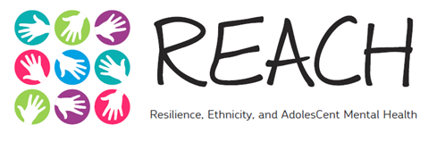

Data Protection Information for Parents/Carers
The REACH study, King’s College London
Dear Parent/Carer,
This leaflet provides information about how we store and use the information we collect as part of this research project, REACH.
Our research team at King’s College London will use information from your child, and your child’s school, in order to undertake this study, and will act as the data controller for this study. This means that we are responsible for looking after this information and using it properly.
All information we collect about your child is stored securely and is completely confidential (private) to the research team. We always store and process information that identifies your child (e.g., name, date of birth) separately to any other information we collect about your child. Only the REACH research team at King’s College London have access to information that identifies your child. We use this information to make sure we use the correct ID number for your child each time they complete a questionnaire for REACH. This process ensures that your child’s name is not on any of the questionnaires they complete for this study. We may share anonymised research data with other researchers, for research purposes only. You child will not be identifiable in any reports or publications summarising our research findings. We will keep information collected during the study for no longer than 7 years after the study has finished.
Your rights to access, change, or move your information are limited, as we need to manage your information in specific ways in order for the research to be reliable and accurate. If you or your child withdraw from the study, we will destroy all information about your child, except the minimum person-identifiable information required to ensure we do not ask your child to take part next time we visit the school, in-person or virtually, to continue the research. To safeguard your child’s rights, we will use the minimum person-identifiable information possible.
As noted in the information sheet, we may also request some information from your child’s school, e.g., about how he/she is getting on at school, his/her behaviour and emotions in class, and whether he/she is receiving any additional support, which is regarded as a special category of information. We will use this information to corroborate information provided by your child. We will always store and process this information separately from any information that identifies your child.
You can find out more about how we use your child’s information at www.thereachstudy.com, or by contacting the project coordinator, Gemma Knowles, at reach@kcl.ac.uk.
Kind regards,
Professor Craig Morgan
Principal Investigator

